Final Project Report

|  |  |
| --- | --- |
| Date | 14.04.25 |
| Team ID | SWTID1744365286 |
| Project Name | Online movie ticket booking system |
| Maximum Marks | 4 marks |

# INTRODUCTION

* 1. Project Overview

The Online Movie Booking System is a web-based application designed to automate and streamline the movie ticket booking process for users and theater administrators. It allows users to browse currently available movies, view showtimes, select preferred seats, and make secure online payments for tickets. The system provides real-time seat availability, reduces manual effort, and eliminates the need to stand in queues.

For administrators, the platform offers functionalities to manage movie listings, schedule show timings, monitor bookings, and generate reports. The system aims to enhance user convenience, improve operational efficiency for cinema halls, and offer a smooth, responsive, and secure booking experience.

The Online Movie Ticket Booking System is a dynamic, interactive, and scalable web application, and the MERN Stack provides an ideal framework to build and manage it efficiently. Here's how each component contributes to the system:

The **MERN stack** (MongoDB, Express.js, React.js, Node.js) plays a crucial role in building a robust and efficient **Online Movie Ticket Booking System**. In this system, **MongoDB** is used as the database to store structured data such as user information, movie details, show timings, seat layouts, and booking records. Its flexible document-based structure makes it ideal for managing nested data like multiple showtimes and seat arrangements. **Express.js** serves as the back-end framework, handling server-side routing, RESTful API creation, and processing client requests such as booking tickets, retrieving show details, and handling user authentication. **React.js** powers the front-end, offering a dynamic and user-friendly interface where users can browse movies, select showtimes, view available seats in real-time, and complete bookings. React’s component-based architecture ensures fast rendering and a seamless user experience. **Node.js** serves as the runtime environment for executing server-side code and managing asynchronous operations such as database access and API responses. It allows real-time interaction between the client and server, especially during critical processes like seat selection and booking confirmation. Together, the MERN stack provides a full JavaScript-based solution that ensures scalability, maintainability, and a smooth end-to-end user experience for online movie ticket booking.

* 1. Purpose

The purpose of an **Online Movie Booking System** is to streamline and digitalize the traditional process of purchasing movie tickets by providing users with an efficient, user-friendly, and accessible platform. This system allows users to explore currently running and upcoming movies, view detailed information such as genre, language, rating, and duration, and select their preferred showtimes and seats—all from the comfort of their home or on-the-go. With real-time seat availability and instant booking confirmation, it eliminates the need to stand in long queues at cinema counters, saving both time and effort.

The system also enhances the experience by allowing users to securely pay for tickets online using integrated payment gateways, and even receive digital receipts or tickets via email or SMS. On the administrative side, the platform equips theater operators with a centralized dashboard to manage movie listings, screen layouts, pricing, seat arrangements, and booking records efficiently. It reduces manual errors, prevents overbooking, and provides valuable insights through booking analytics and reports. The system is scalable, allowing integration with multiple theaters and multiplexes. Ultimately, the Online Movie Booking System benefits both customers and cinema owners by providing convenience, security, transparency, and improved overall management through automation and modern web technologies.

# IDEATION PHASE

* 1. Problem Statement:

Customers who enjoy watching movies and prefer booking tickets online often face difficulties when using current platforms. They want a quick and hassle-free way to search for movies, select seats, and make payments—especially from their phones while on the go. However, they frequently encounter problems like unresponsive mobile interfaces, confusing seat layouts, app crashes, or payment failures. These barriers cause frustration and may lead them to abandon the process entirely. A better, more intuitive solution is needed to enhance their booking experience and meet their expectations for speed, ease, and reliability.

|  |  |
| --- | --- |
| I am | a busy, tech-savvy movie enthusiast who values convenience and digital experiences |
| I'm trying to | book movie tickets quickly and choose the best seats without standing in long queues |
| but | I often face limited seat availability and confusing interfaces that slow down my booking |
| because | current platforms either lack real-time seat tracking, are not personalized, or are cluttered |
| which makes me feel | frustrated and stressed, making me avoid booking or miss good shows |

|  |  |  |  |  |
| --- | --- | --- | --- | --- |
| I am A busy, tech-savvy movie enthusiast who values convenience and digital experiences | I am trying to book movie tickets smoothly using a mobile app or website without delays or confusion. | But I often face last-minute booking failures, poor seat layouts, and payment issues. | Because the platform lacks real-time seat updates, is poorly optimized for mobile, and crashes during high traffic. | Which makes me feel  irritated, anxious, and disappointed—especially when I miss out on my preferred movie or showtime. |

|  |  |  |  |  |  |
| --- | --- | --- | --- | --- | --- |
| **Problem Statement (PS)** | **I am (Customer)** | **I’m trying to** | **But** | **Because** | **Which makes me feel** |
| PS-1 | a movie lover | book a movie ticket quickly from my mobile | the app keeps crashing or freezing | it is not optimized for mobile and cannot handle peak traffic | frustrated |
| PS-2 | |  | | --- | |  |  |  | | --- | | a working professional | | book a last-minute ticket for an evening show | I face delays and confusing seat selection | UI not user friendly | anxious and annoyed |

* 1. Empathy Map Canvas

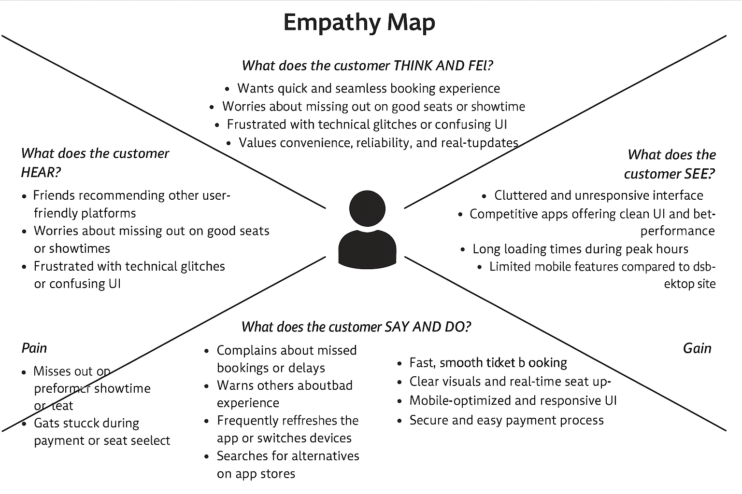

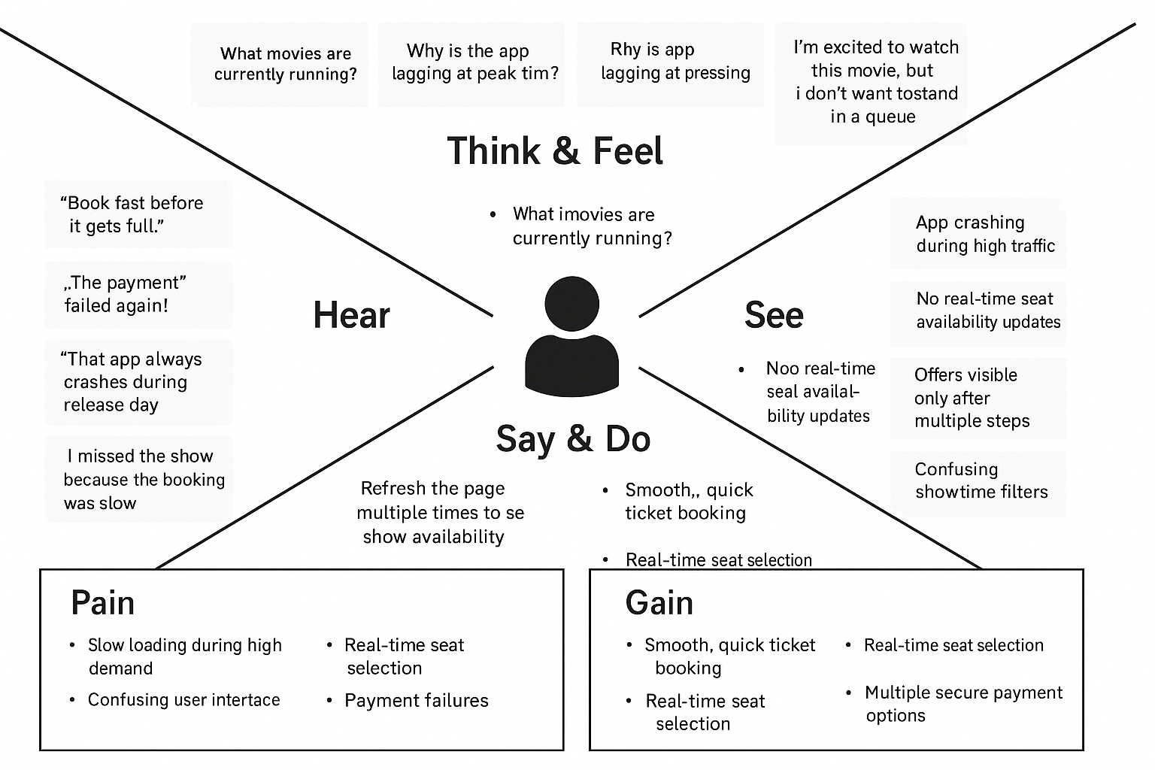

* 1. Brainstorming

**Brainstorm & Idea Prioritization Template:**

Brainstorming provides a free and open environment that encourages everyone within a team to participate in the creative thinking process that leads to problem solving. Prioritizing volume over value, out-of-the-box ideas are welcome and built upon, and all participants are encouraged to collaborate, helping each other develop a rich amount of creative solutions.

**Step-1: Team Gathering, Collaboration and Select the Problem Statement:**

**Problem Statement:** In a fast-paced world where people value convenience and efficiency, moviegoers face challenges such as long queues at theaters, lack of real-time seat availability, and poor booking interfaces. Our aim is to develop an intuitive and responsive online movie ticket booking platform, iMovies, that streamlines the process of selecting movies, showtimes, and seats, while providing a personalized and seamless user experience.

**Step-2: Brainstorm, Idea Listing and Grouping**

**Raw Ideas:**

* User authentication and profile management
* Browse movies by genre, language, or theater
* Real-time seat availability visualization
* Showtimes filtering by location and timing
* Add movies to a watchlist
* Secure payment integration
* Booking history and digital tickets
* Backend API for managing users, bookings, movies, and shows
* Admin panel for adding/editing shows and theaters
* Notifications for upcoming shows or booking reminders
* Mobile responsive design
* Dark/light theme toggle
* Guest login or OTP-based login
* Rating & reviews for movies

**Grouped Ideas:**

User Experience & Interface:

* Browse/filter movies
* Watchlist
* Rating/reviews
* Theme toggle
* Responsive design

Booking Functionality:

* Real-time seat layout
* Showtimes by location
* Secure payment gateway
* Booking history

Backend & Infrastructure;

* RESTful APIs with Express.js
* MongoDB collections for users, bookings, theaters, etc.
* Admin dashboard
* Notifications
* Discount code management

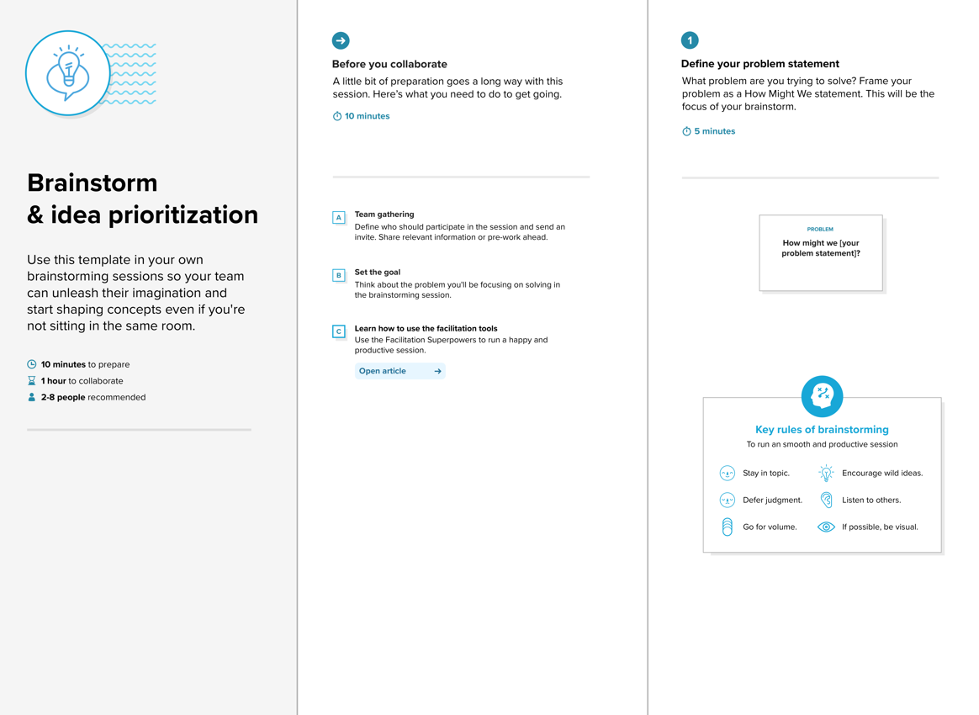

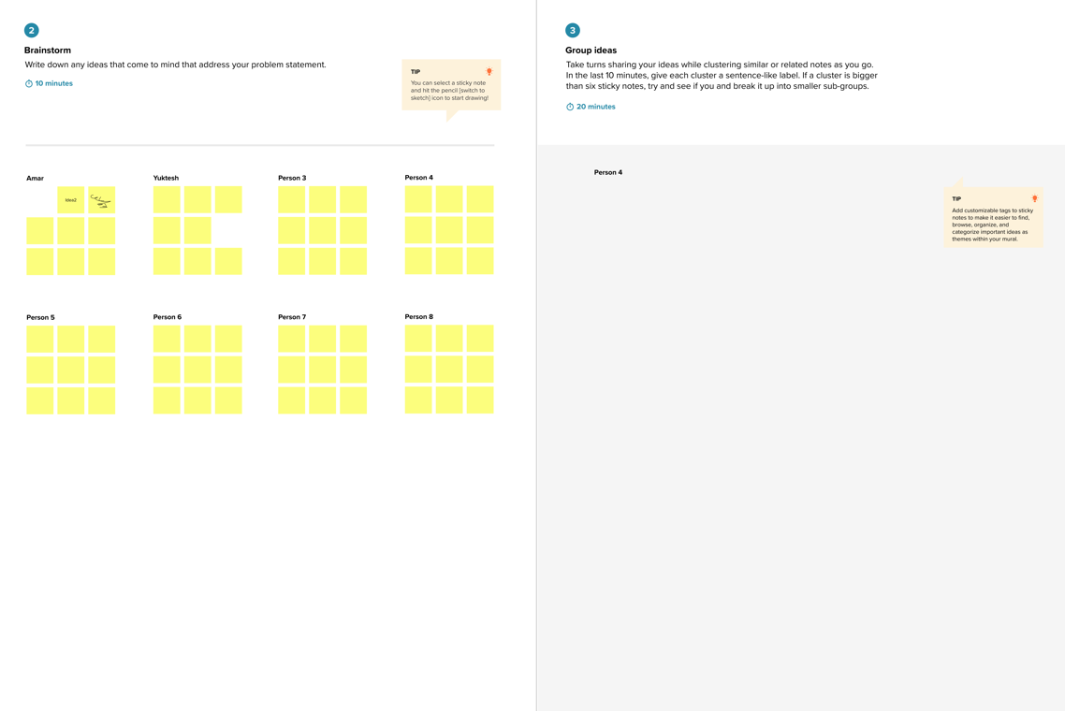

# REQUIREMENT ANALYSIS

* 1. Solution Requirement

**Functional Requirements:**  
Following are the functional requirements of the proposed movie ticket booking system.

|  |  |  |
| --- | --- | --- |
| **FR No.** | **Functional Requirement (Epic)** | **Sub Requirement (Story / Sub-Task)** |
| FR-1 | User Registration | Registration through Form, Registration through Gmail, Registration through LinkedIn |
| FR-2 | User Confirmation | Confirmation via Email, Confirmation via OTP |
| FR-3 | Movie Selection | Browse Movies by Genre, Language, Rating |
| FR-4 | Seat Selection | Select Available Seats, Show Seat Layout |
| FR-5 | Payment Processing | Payment via Credit/Debit Card, Payment via UPI/Wallets, Apply Discount Coupons |
| FR-6 | Ticket Generation | Generate e-Ticket, Send Ticket via Email/SMS |
| FR-7 | Booking History | View Past Bookings, Download Invoices |
| FR-8 | Cancellation & Refund | Cancel Ticket, Process Refund Based on Policy |
| FR-9 | Admin Panel | Manage Movie Listings, Manage User Bookings, View Revenue Reports |
| FR-10 | Customer Support | AI Chatbot for FAQs, Live Agent Support |

**Non-functional Requirements:**

Following are the non-functional requirements of the proposed solution.

|  |  |  |
| --- | --- | --- |
| **FR No.** | **Non-Functional Requirement** | **Description** |
| NFR-1 | **Usability** | Intuitive UI/UX, Mobile-friendly Interface |
| NFR-2 | **Security** | Secure Payment Gateway, Data Encryption, Role-based Access Control |
| NFR-3 | **Reliability** | 99.9% Uptime, Robust Error Handling |
| NFR-4 | **Performance** | Optimized Response Time, Load Balancing, Caching Mechanisms |
| NFR-5 | **Availability** | Multi-Region Deployment, Failover Mechanisms |
| NFR-6 | **Scalability** | Microservices Architecture, Auto-scaling of Resources |

* 1. Data Flow Diagram

**Data Flow Diagrams:**

A Data Flow Diagram (DFD) is a traditional visual representation of the information flows within a system. A neat and clear DFD can depict the right amount of the system requirement graphically. It shows how data enters and leaves the system, what changes the information, and where data is stored.

Example: DFD Level 0(Industry Standard)

**Example:** [**(Simplified)**](https://developer.ibm.com/patterns/visualize-unstructured-text/)

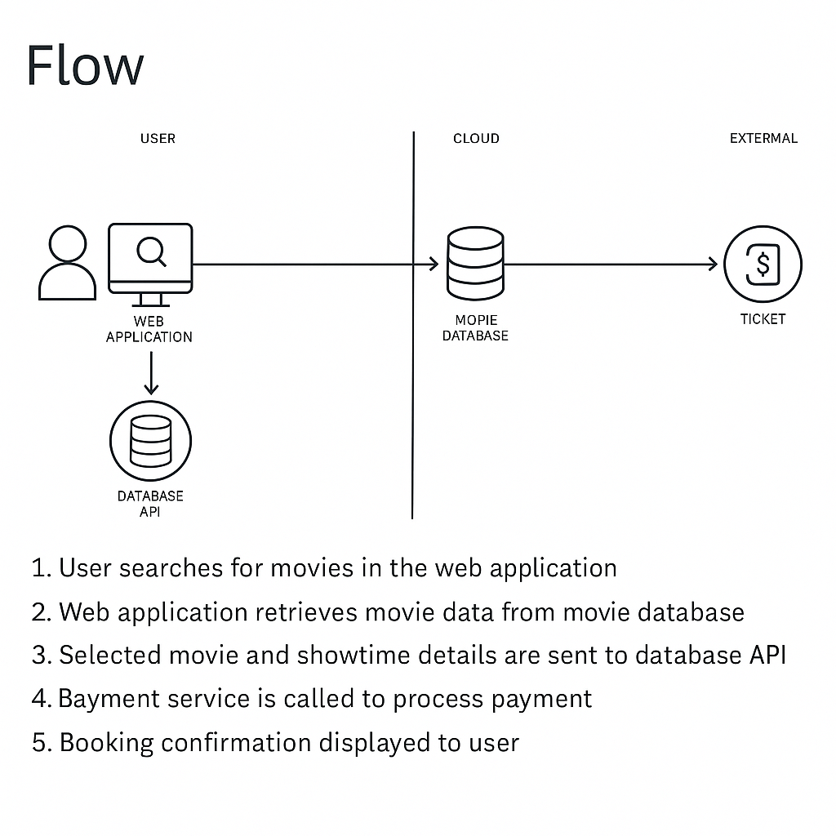

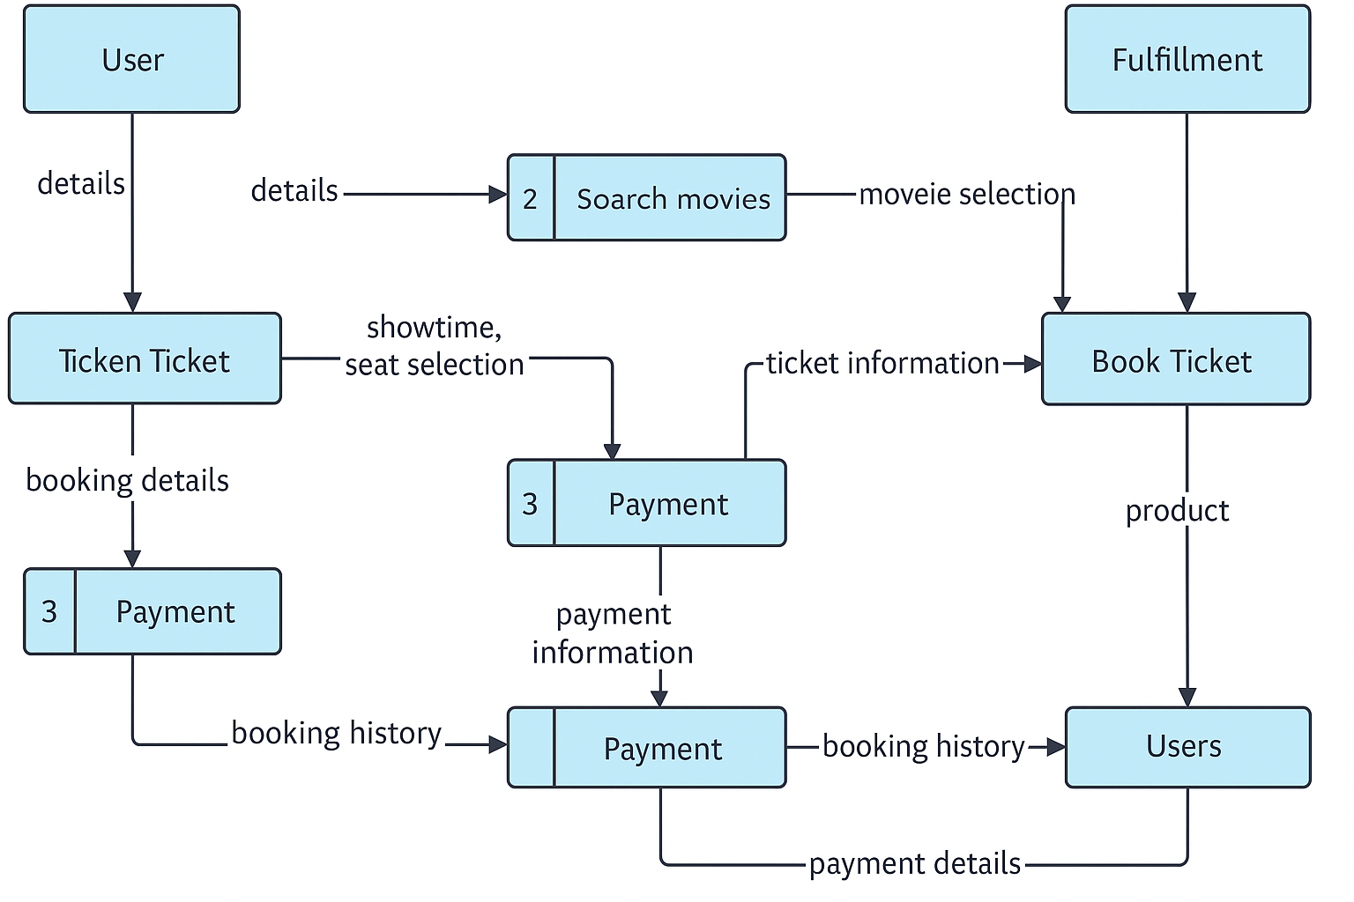

**User Stories**

Use the below template to list all the user stories for the product.

| **User Type** | **Functional Requirement (Epic)** | **User Story Number** | **User Story / Task** | **Acceptance criteria** | **Priority** | **Release** |
| --- | --- | --- | --- | --- | --- | --- |
| Customer (Mobile user) | Registration | USN-1 | As a user, I can register for the application by entering my email, password, and confirming my password. | I can access my account / dashboard | High | Sprint-1 |
|  |  | USN-2 | As a user, I will receive confirmation email once I have registered for the application | I can receive confirmation email & click confirm | High | Sprint-1 |
|  |  | USN-3 | As a user, I can register for the application through Facebook | I can register & access the dashboard with Facebook Login | Low | Sprint-2 |
|  |  | USN-4 | As a user, I can register for the application through Gmail | I can register & access the dashboard with Gmail Login. | Medium | Sprint-1 |
|  | Login | USN-5 | As a user, I can log into the application by entering email & password | I can successfully log in and access my account. | High | Sprint-1 |
|  | Search & Browse Movie | USN-6 | As a user, I can browse currently available movies by genre, language, and format (2D/3D/IMAX). | I can view and filter movies based on my preferences. | |  | | --- | | High |  |  | | --- | |  | | Sprint-1 |
|  | Seat selection | USN-7 | As a user, I can select my preferred seats before booking. | I can view the seating layout and pick available seats. | High | |  | | --- | | Sprint-1 |  |  | | --- | |  | |
|  | Payment | USN-8 | As a user, I can pay for my ticket using a credit card, debit card, UPI, or digital wallets. | |  | | --- | | I receive a successful transaction message and my ticket is booked. |  |  | | --- | |  | | |  | | --- | | High |  |  | | --- | |  | | |  | | --- | | Sprint-1 |  |  | | --- | |  | |
|  | |  | | --- | | Ticket Confirmation |  |  | | --- | |  | | USN-9 | As a user, I receive an email and SMS confirmation after booking my ticket. | |  | | --- | | I get a ticket with a QR code and details of my movie. |  |  | | --- | |  | | Medium | Sprint-2 |
| Customer (Web user) | |  | | --- | | User Support |  |  | | --- | |  | | USN-10 | |  |  |  | | --- | --- | --- | | |  | | --- | | As a web user, I can register and log in using email, Gmail, or Facebook. |  |  | | --- | |  | |  |  | | --- | |  | | |  |  |  | | --- | --- | --- | | |  | | --- | | I can access my account and book tickets. |  |  | | --- | |  | |  |  | | --- | |  | | |  | | --- | |  |   High | Sprint-1 |
| Customer Care Executive | |  | | --- | | Manage Movies & Shows |  |  | | --- | |  | | USN-11 | |  | | --- | | As an admin, I can add, update, and delete movie listings and showtimes. |  |  | | --- | |  | | |  |  |  | | --- | --- | --- | | |  | | --- | | I can see my ticket history and upcoming shows. |  |  | | --- | |  | |  |  | | --- | |  | | |  | | --- | |  |   Medium | Sprint-2 |
| Administrator |  | USN-12 | |  | | --- | | As a support agent, I can view user details and assist with booking issues. |  |  | | --- | |  | | |  | | --- | | I can resolve user issues and update their booking status. |  |  | | --- | |  | | Medium | Sprint-2 |

* 1. Technology Stack

**Technical Architecture:**

The Deliverable shall include the architectural diagram as below and the information as per the table1 & table 2

**Example: Movie Ticket Booking System**

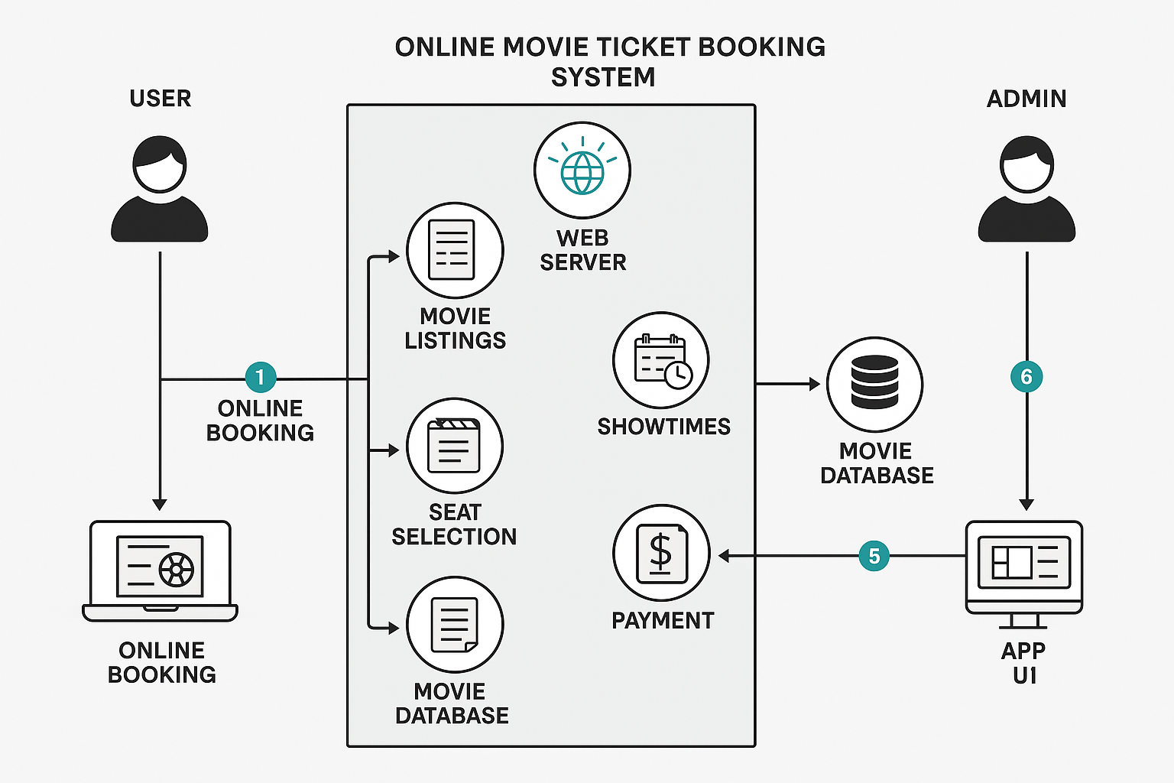

### **Table-1: Components & Technologies**

|  |  |  |  |
| --- | --- | --- | --- |
| **S.No** | **Component** | **Description** | **Technology** |
| 1 | User Interface | How user interacts with the application, e.g., Web UI, Mobile App | HTML, CSS, JavaScript / React.js / Angular.js / Flutter / Swift |
| 2 | Application Logic-1 | Logic for user authentication and profile management | Java / Python / Node.js |
| 3 | Application Logic-2 | Logic for ticket booking, seat selection, and payment processing | IBM Watson STT service, Payment Gateway APIs |
| 4 | Application Logic-3 | AI-powered chatbot for customer support | IBM Watson Assistant |
| 5 | Database | Data storage for users, bookings, movie details, etc. | MySQL, PostgreSQL, NoSQL |
| 6 | Cloud Database | Cloud-based data storage solution | IBM DB2, IBM Cloudant, Firebase Firestore |
| 7 | File Storage | Storing user-generated content, e.g., ticket receipts | IBM Block Storage, Local Filesystem, AWS S3 |
| 8 | External API-1 | Third-party API for real-time movie listings | IMDb API, TMDb API |
| 9 | External API-2 | Identity verification during booking | Aadhar API, OAuth 2.0 Authentication |
| 10 | Machine Learning Model | Personalized movie recommendations based on user behavior | Recommendation Engine (TensorFlow, PyTorch) |
| 11 | Infrastructure (Server / Cloud) | Application Deployment on Local System / Cloud | Cloud Foundry, Kubernetes, AWS, IBM Cloud |

**Table-2: Application Characteristics:**

|  |  |  |  |
| --- | --- | --- | --- |
| S.No | Characteristics | Description | Technology |
| 1 | Open-Source Frameworks | Frameworks used for development | React.js, Node.js, Express.js, Django |
| 2 | Security Implementations | Security controls for user data and transactions | SHA-256 encryption, IAM Controls, OAuth, Firewalls |
| 3 | Scalable Architecture | Ensuring the system scales for high demand | Microservices, Load Balancing |
| 4 | Availability | High availability with redundancy measures | Distributed Servers, Failover Mechanisms |
| 5 | Performance | Optimization techniques for fast response times | Caching (Redis, Memcached), CDN Integration |

# PROJECT DESIGN

* 1. Problem Solution Fit

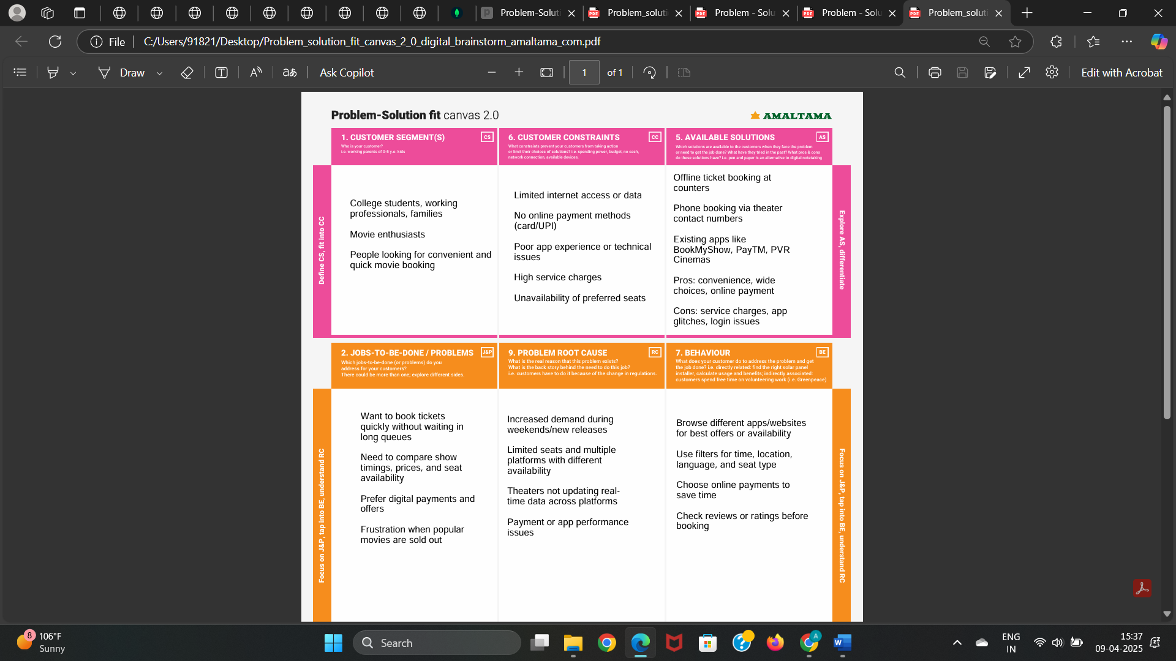

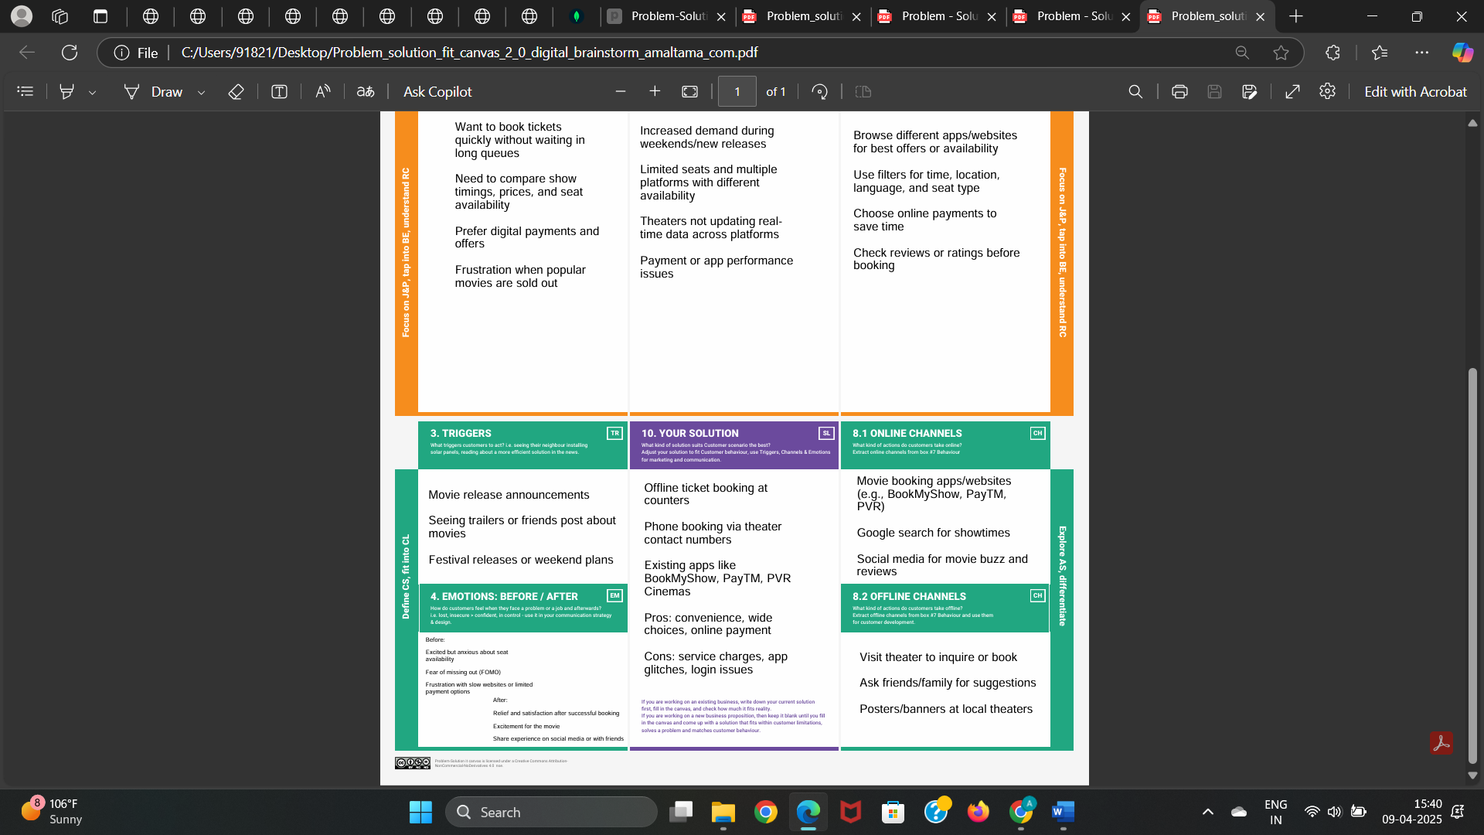

* 1. Proposed Solution

|  |  |  |
| --- | --- | --- |
| **S.No.** | **Parameter** | **Description** |
|  | Problem Statement (Problem to be solved) | Customers often struggle with slow, unreliable, or non-intuitive movie booking platforms that fail to offer real-time seat tracking, secure payments, or a personalized experience. |
|  | Idea / Solution description | iMovies is a smart, user-friendly movie ticket booking platform that allows users to browse movies, select showtimes, and book seats with real-time availability. The app integrates secure payments, booking history, and user preferences using Express.js (backend), MongoDB (database), and a responsive frontend. |
|  | Novelty / Uniqueness | Real-time seat availability, seamless payment integration, intuitive interface, and a customizable user experience make iMovies stand out. Personalized movie recommendations and loyalty rewards further enhance engagement. |
|  | Social Impact / Customer Satisfaction | Reduces physical queues and booking stress, especially for elderly or busy users. Promotes digital convenience, enhances user satisfaction, and supports safer, contactless ticketing. |
|  | Business Model (Revenue Model) | iMovies can generate revenue through service charges, in-app promotions, theater partnerships, and optional premium features (e.g., early access to bookings, cashback offers)  . |
|  | Scalability of the Solution | The solution is highly scalable, with a modular architecture built on Express.js and MongoDB. It can support regional theater integrations, international language support, and user expansion through cloud hosting. |

* 1. Solution Architecture

Solution Architecture Diagram:

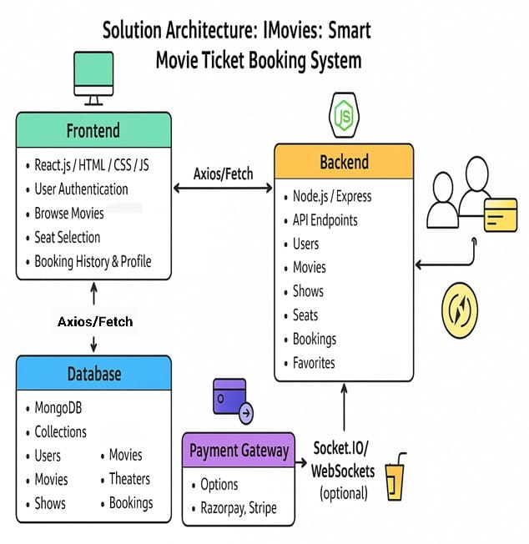

# PROJECT PLANNING & SCHEDULING

* 1. Project Planning

**Product Backlog, Sprint Schedule, and Estimation**

| **Sprint** | **Functional Requirement (Epic)** | **User Story Number** | **User Story / Task** | **Story Points** | **Priority** | **Team Members** |
| --- | --- | --- | --- | --- | --- | --- |
| Sprint-1 | Registration | USN-1 | As a user, I can register for the application by entering my email, password, and confirming my password. | 2 | High | Aniket |
| Sprint-1 | Registration | USN-2 | As a user, I will receive confirmation email once I have registered for the application | 1 | High | Aprajita |
| Sprint-2 | Registration | USN-3 | As a user, I can register for the application through Facebook | 2 | Low | Komal |
| Sprint-1 | Registration | USN-4 | As a user, I can register for the application through Gmail | 2 | Medium | Arpita |
| Sprint-1 | Login | USN-5 | As a user, I can log into the application by entering email & password | 1 | High | Komal |
| Sprint-2 | Movie Browsing | USN-6 | As a user, I can browse a list of movies and showtimes | 2 | High | Aprajita |
| Sprint-2 | Seat Selection | USN-7 | As a user, I can view seating layout and select my seats | 3 | High | Aniket |
| Sprint-2 | Ticket Booking | USN-8 | As a user, I can book tickets for selected movie, show, and seats | 3 | High | Arpita |
| Sprint-3 | Payments | USN-9 | As a user, I can pay securely via an integrated payment gateway | 5 | High | Aniket |
| Sprint-3 | Confirmation | USN-10 | As a user, I receive a confirmation with all booking details | 2 | Medium | Aprajita |
| Sprint-3 | Deployment | USN-11 | As a user, I can access the deployed application online | 3 | Medium | Komal |

**Project Tracker, Velocity & Burndown Chart: (4 Marks)**

| **Sprint** | **Total Story Points** | **Duration** | **Sprint Start Date** | **Sprint End Date (Planned)** | **Story Points Completed (as on Planned End Date)** | **Sprint Release Date (Actual)** |
| --- | --- | --- | --- | --- | --- | --- |
| Sprint-1 | 10 | 5 Days | 01 Apr 2025 | 05 Apr 2025 | 10 | 05 Apr 2025 |
| Sprint-2 | 15 | 5 Days | 06 Apr 2025 | 10 Apr 2025 | 15 | 10 Apr 2025 |
| Sprint-3 | 13 | 5 Days | 11 Apr 2025 | 15 Apr 2025 | 13 | 15 Apr 2025 |
| Sprint-4 | 0 | - | - | - | - | - |

**Velocity:**

Imagine we have a 10-day sprint duration, and the velocity of the team is 20 (points per sprint). Let’s calculate the team’s average velocity (AV) per iteration unit (story points per day)

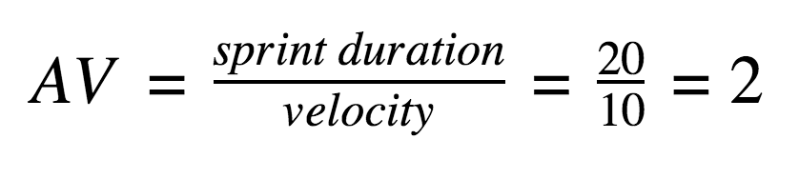

**Burndown Chart:**

A burn down chart is a graphical representation of work left to do versus time. It is often used in agile[software development](https://www.visual-paradigm.com/scrum/what-is-agile-software-development/) methodologies such as [Scrum](https://www.visual-paradigm.com/scrum/scrum-in-3-minutes/). However, burn down charts can be applied to any project containing measurable progress over time.

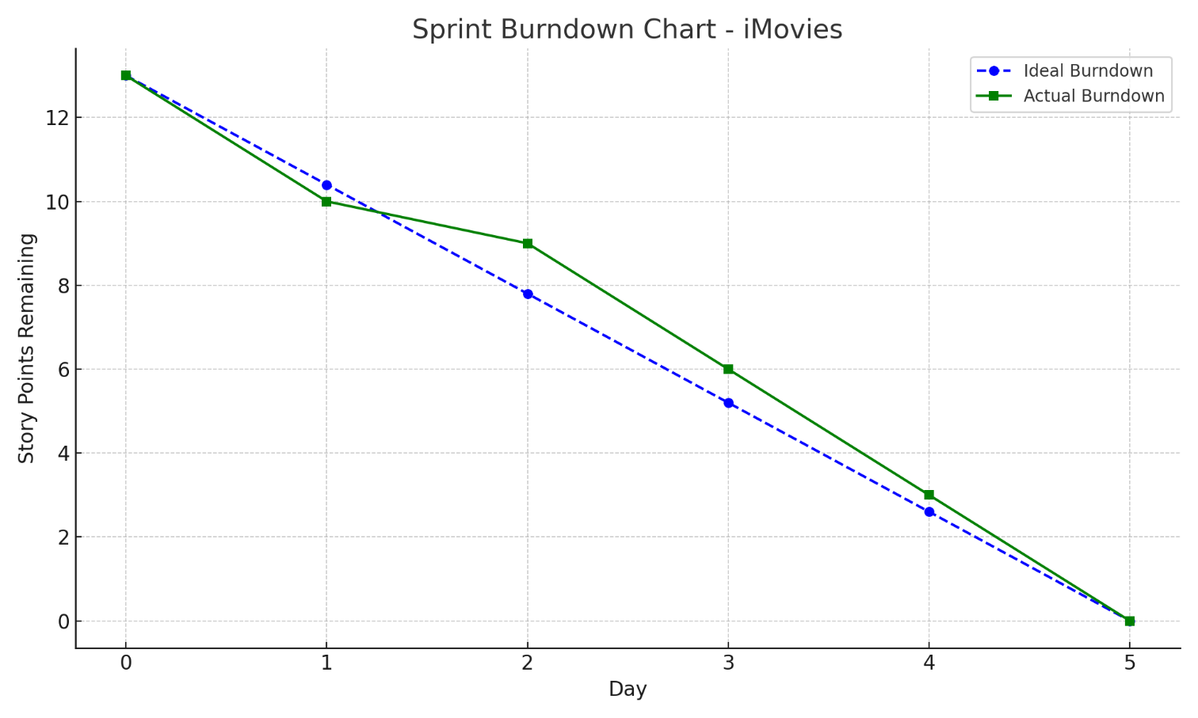

# FUNCTIONAL AND PERFORMANCE TESTING

* 1. Performance Testing

Testing Period: 1.02.25 to 14.04.25

**Testing Scope:**

List of Features and Functionalities to be Tested:

• User registration and login

• Movie listing and search functionality

• Movie details page (including showtimes, ratings, etc.)

• Seat selection and booking flow

• Payment gateway integration

• Booking confirmation and email/SMS notifications

• User profile management (viewing past bookings, updating details)

• Ticket cancellation and refund process

• Mobile responsiveness and cross-browser compatibility

• Admin panel functionalities (manage movies, shows, and booking

**List of User Stories or Requirements to be Tested:**

• As a user, I want to browse movies and view showtimes so I can choose the right movie and time.

• As a user, I want to securely make payments for tickets online.

• As a user, I want to receive a booking confirmation via email and SMS.

• As an admin, I want to add, edit, or remove movies from the platform.

**Testing Environment:**

URL/Location: [Web URL or Application Location]

Credentials (if required): [Username/Password]

**Test Cases:**

| **Test Case ID** | **Test Scenario** | **Test Steps** | **Expected Result** | **Actual Result** | **Pass/Fail** |
| --- | --- | --- | --- | --- | --- |
| TC-001 | User Registration | 1. Navigate to the registration page. 2. Enter valid user details. 3. Click "Submit". | User should be registered successfully and redirected to the login page. | [Record Result] | [Pass/Fail] |
| TC-002 | Movie Search | 1. Navigate to the movie listing page. 2. Enter a movie title in the search bar. 3. Click "Search". | Matching movies should be displayed based on the search term. | [Record Result] | [Pass/Fail] |
| TC-003 | Seat Selection | 1. Select a movie. 2. Choose a showtime. 3. Select available seats. 4. Click "Book Tickets". | Seats should be booked, and a booking summary should be shown. | [Record Result] | [Pass/Fail] |
| TC-004 | Payment Process | 1. Select seats and proceed to checkout. 2. Enter payment details. 3. Click "Pay Now". | Payment should be processed, and a confirmation page should be shown. | [Record Result] | [Pass/Fail] |
| TC-005 | Admin Adding Movie | 1. Log in as admin. 2. Navigate to the admin panel. 3. Click "Add Movie". 4. Fill in movie details and click "Save". | Movie should be added to the movie list in the system. | [Record Result] | [Pass/Fail] |
| TC-006 | Responsiv Design | 1.Open the site on different devices (mobile, tablet, desktop). 2. Verify if the UI adapts to different screen sizes. | The website should be fully responsive and display correctly on all devices. | [Record Result] | [Pass/Fail] |

**Bug Tracking:**

| **Bug ID** | **Bug Description** | **Steps to Reproduce** | **Severity** | **Status** | **Additional Feedback** |
| --- | --- | --- | --- | --- | --- |
| BG-001 | Payment gateway not processing payments correctly | 1. Select seats. 2. Proceed to checkout. 3. Enter payment details and click "Pay Now". 4. Error message displayed. | High | Open | Payment processing fails intermittently. |
| BG-002 | Movie search returns incorrect results | 1. Enter a movie title in the search bar. 2. Click "Search". 3. Incorrect or no results displayed. | Medium | In Progress | Search algorithm might need refinement. |
| BG-003 | Admin unable to remove movies from the list | 1. Log in as admin. 2. Navigate to the admin panel. 3. Attempt to delete a movie. 4. Movie is not removed. | High | Open | There may be a backend issue with movie deletion. |

**Sign-off:**

Tester Name: Aniket Ranjan

Date: 14.04.25

# RESULTS

* 1. Output screenshots

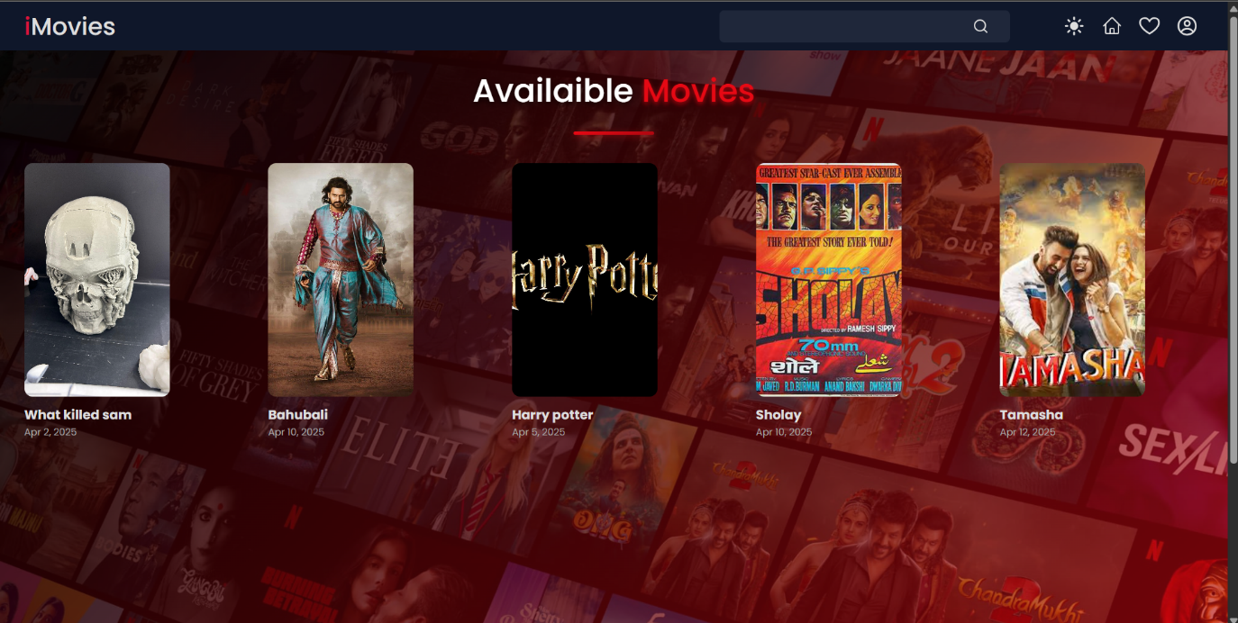

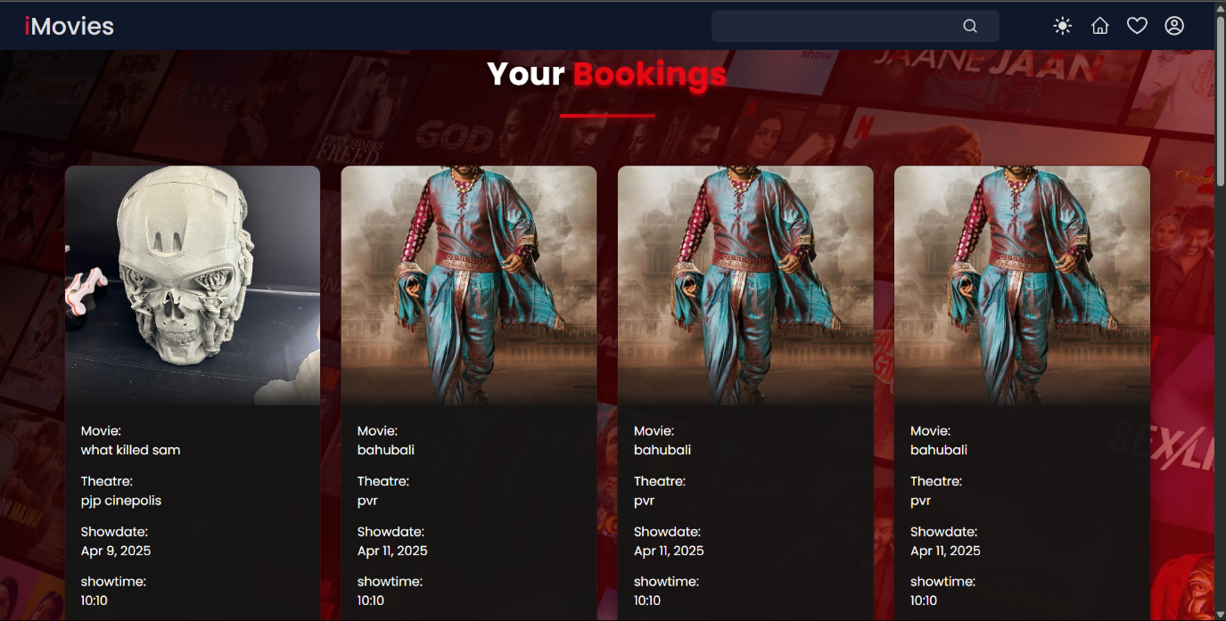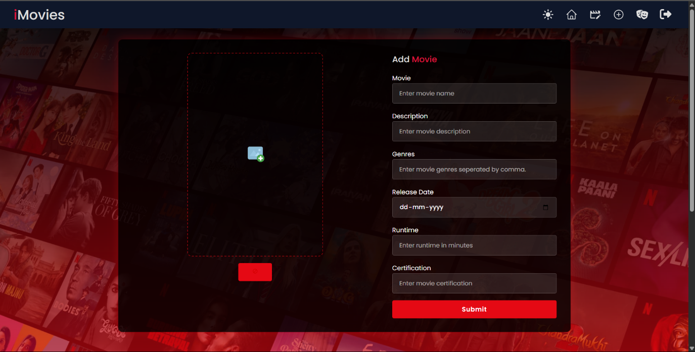

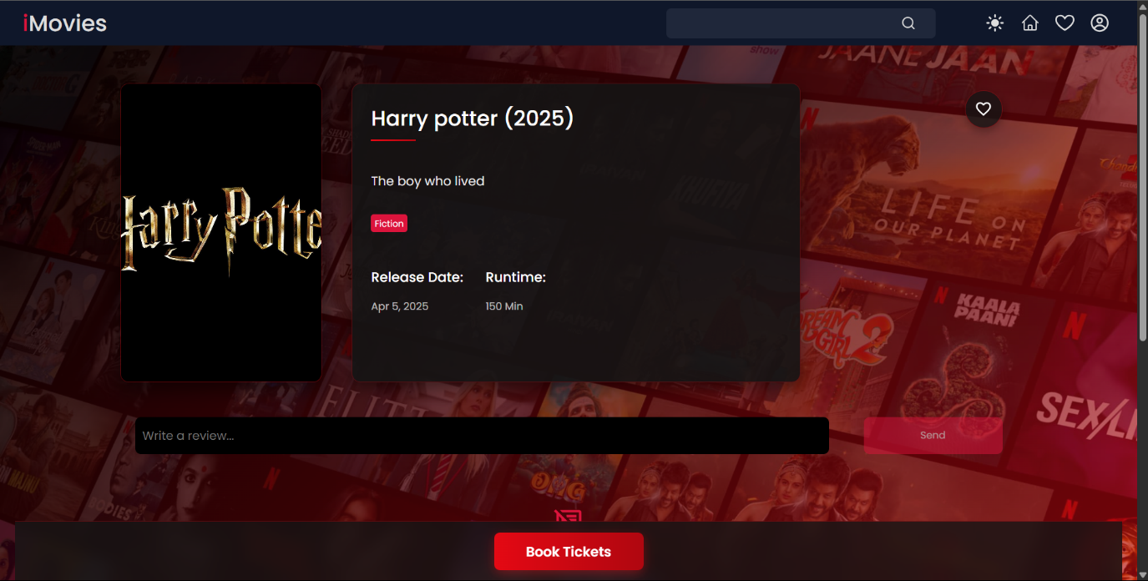

1. **ADVANTAGES & DISADVANTAGES**

**Advantages:**

1. 24/7 Availability

Users can book tickets anytime without depending on office hours.

1. Real-Time Seat Management

Shows up-to-date seat availability and prevents overbooking through dynamic updates.

1. User Convenience

Reduces queue time and provides a seamless booking experience via web/mobile.

1. Automated Payment Integration
   * Secures transactions through payment gateways (e.g., Razorpay, Stripe).
2. Centralized Data Management
   * Admins can manage movie listings, showtimes, user data, and transactions in one place (via MongoDB/SQL).
3. Paperless System
   * E-tickets reduce printing costs and are eco-friendly.
4. Scalable Architecture
   * Supports thousands of concurrent users using technologies like MongoDB, React, and Node.js.
5. Reports & Analytics
   * Tracks user behavior, peak showtimes, and revenue statistics for better decision-making.

**Disadvantages:**

1. Internet Dependency
   * Requires stable internet access for both users and system operations.
2. Security Concerns
   * Sensitive data like payment and personal details need protection from cyber threats (must implement SSL, encryption, etc.).
3. Technical Glitches
   * Downtime or bugs in the system can lead to booking failures or user frustration.
4. Initial Development Cost
   * Requires time and investment in web hosting, backend, UI/UX, and security.
5. Digital Literacy Requirement
   * Not all users (especially elderly) may be comfortable using online platforms.
6. High Server Load During Peak Times
   * May slow down or crash if not scaled with load balancers or cloud resources.
7. **CONCLUSION**

The Online Ticket Booking System offers a convenient, user-friendly platform for customers to browse movies, select showtimes, and book tickets effortlessly. It streamlines the ticketing process, eliminating long queues and manual operations. With real-time availability and secure payment options, it provides a seamless booking experience. This system enhances operational efficiency for cinemas, improves customer satisfaction, and allows businesses to manage bookings and data more effectively, offering a modern solution to the entertainment industry.

1. **FUTURE SCOPE**

The future scope of an online ticket booking system includes:

1. **Integration with AI & ML**: Personalized recommendations and predictive analytics for better user experiences.
2. **Mobile App Enhancements**: More advanced mobile apps with features like augmented reality (AR) for virtual seat selection and location-based services.
3. **Blockchain**: For enhanced security, preventing fraud, and ensuring transparency in ticket transactions.
4. **Event & Multi-platform Integration**: Integration with multiple event platforms for a wider range of bookings (e.g., concerts, conferences).
5. **Voice & Chatbot Booking**: Enabling users to book tickets via voice assistants or chatbots, making the system more accessible.
6. **Green Initiatives**: E-ticketing with eco-friendly policies, reducing paper usage.
7. **Global Expansion**: Extending the system’s reach to more regions and languages, offering multi-currency and multi-lingual support.
8. **APPENDIX**

**Source code:**

<https://github.com/AniketRanjan-Creates/iMovies-Movie-Ticket-Booking-System>

Demo link:

<https://drive.google.com/file/d/1njEv2iaXIvOHSztpjdL7SAvaJx1-XF3-/view?usp=drivesdk>